**AGAS User Manual**

**INTRODUCTION –** When you open the app for the first time you will be directed into our small introduction of the app. Below the screen you can see 2 arrows, If you click the right arrow facing downwards, the introduction screen will be skipped and you will be directed to our home menu. If you click the right arrow the introduction screen will scroll to the next introduction screen. There are 4 parts of introduction screen and after that you will be directed to the home menu.

**HOME MENU –** This is the home menu on our application. Inside the home menu you can see the navigation bar and Add Pill button below the screen. When you press the Add Pill button you will be directed to the another screen of the app which you will set your reminders. The navigation bar has 3 categories. Pills is where you can see your medicine that you set to remind you. History is where you can see when did you take your medicine and lastly Settings of our app where the user can change there notification sounds, application theme and reminder settings.

**ADD PILL –** When you press Add Pill button on the home menu you will be directed here. You can see 6 categories. Medicine Name, Medicine Description, Color, Photo, Reminders and Intake Options. Medicine Name is where you will input your medicine name by clicking the text box and start typing. Same concept on how you will input your medicine description. Color will help the user to navigate there medicine on the history menu. Reminders is where the user can set there time and how many medicine or pills that they will take on one take. Lastly Intake options is where the user can set on how they will drink there medicine if it’s everyday, duration or custom intervals.

**ADDING IMAGE –** If you want to add an Image of your medicine that you want to remind you, you will click the image icon and you will be ask to choose if you want to take a picture of your medicine or if you have already the picture or the image of that medicine you can click gallery and upload your image to the app.

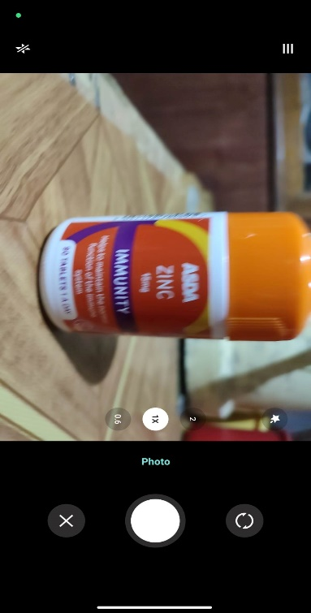

**TAKING A PICTURE –** If you click the camera you will be directed to your phone camera. Once you will take a picture of your medicine press your shutter button on your screen.

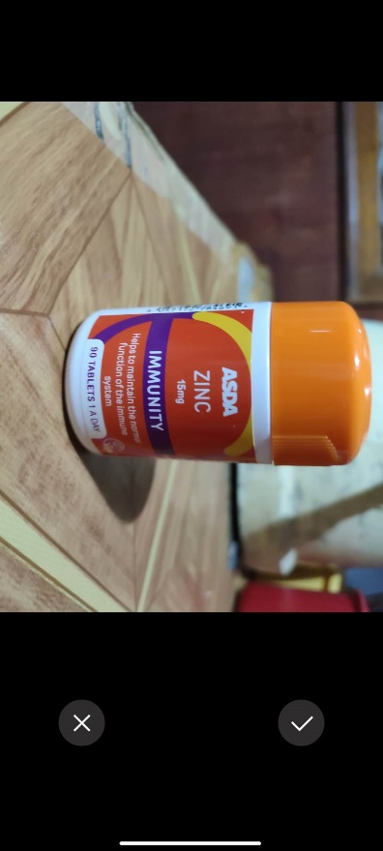

**PICTURE HAS BEEN TAKEN –** If you have already pressed the shutter button you will be directed here by pressing X you want to try again to take another picture of that medicine and by pressing check you will be directed to the editing screen of the image.

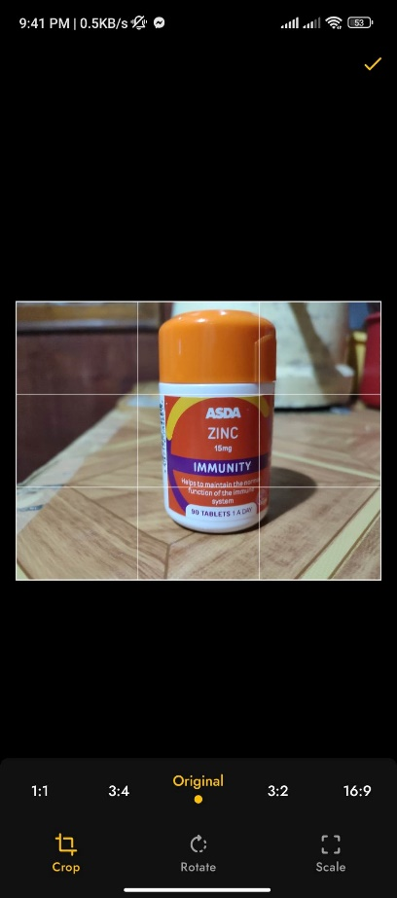

**EDITING IMAGE –** After taking a picture of your medicine and clicking check mark icon on the previous step, you will be directed here if you want to edit your image. After editing your image or you don’t want to edit your image press the check icon on the top right of your screen

**Image uploaded –** Once your done editing your image you can see that the background of the photo icon is the medicine that you have uploaded.

**Set a Reminder –** If you click Add Reminder a window will be pop out below the screen and there are 3 categories. Reminder time, amount and save reminder. You can set many reminders on one day by just clicking Add Reminder. If you are done editing the time and amount of pills or medicine that you will take just click save reminder and that pop out will automatically close and you will see the reminder that you set below the Reminders title

**Set a Reminder Time –** If you click the Set reminder time a clock will be shown on the screen. The user can adjust the time by adjusting the needle of the clock or if the user clicks the keyboard icon below the clock, the user can input the numbers of the clock manually. If you have already set the time that you will take your medicine just click OK.

**Set Amount –** If you click the Set Amount a pop out screen will be shown. The user will swipe left and right. Swipe left will be increasing by 0.25 and swiping right will be decreasing by 0.25. After setting an amount just click OK and Save Reminder. Your reminder time and amount is already set!.

**Intake Options –** Lastly by setting up your reminder is the intake options. Intake options can be set into Everyday, Duration and Custom Intervals. If you choose Everyday the app will remind you everyday on the same time that you set on the Reminders category. Duration is where the app will remind you on how many days that you set. Custom Intervals is when the app will remind you on how many days that you will drink that medicine and how many days that you will not drink that medicine.

**Intake Options –** Duration and Custom Intervals have Reminders or Instructions on how the reminder works when you choose one of them. Reminders or Notice label are being shown below.

**Change how many days –** By clicking the label you can set how many duration days, days active and days inactive by swiping left and right. Swiping left will increase the number and swiping right will decrease the number. After setting the days click OK!.

**Saving –** Once you finish setting up your reminder click the floppy disk icon or the Save icon itself below. Your reminder is now placed and shown on the home screen after you saved your reminder

**History –** On the history page you can see you overview of the medicines that you set to remind also the charts. The charts are shown how many percent did you take your medicine and how many percent that you missed your medicine. These charts are real time update if you confirm or mmissed the medicine that you will take it will automatically update the charts

**History of the medicine–** If you click the medicine reminder in the history that you set, you will see all the time that the app has reminded you and what time did you take or did not take the medicine. Also it also shows the date that you have taken it. The format of the date is Day – Month.

**Settings –** In the settings menu the user can set the application behaviour by setting how many minutes that you want to delay your medicine that you will drink.

Reminding Again feature will remind the user every minute on how many minutes did the user set on the remind again after.

Set Notification options is where the user can customize the alarm tone and the vibration of the phone when alarmed.

Application Theme can be set into dark mode or light mode.

Lastly will be the About this application. Inside will be the video walkthrough of the app itself.

**Notification or Alarm –** The app will let you know if it is time to drink your medicine. Notification bar will pop out on your Notification panel. The notification panel of the reminder shows the image of the medicine that you will be taking or drinking and inside the application there is a confirm button on top of your screen when the reminder is been triggered.

